Shell-2010-Pecten-RGBpc.wmf

**Onshore Engineering Nigeria**

**(Operations Support & WRFM)**

**ROUTING OF LP NAG TO SOKU AG2/3 COMPRESSOR**

**Opportunity Realisation Note**

Epebiyi, Taiwo

Process Engineer (SPDC-PTE/EUPE)

December 2017

Document Revision: **R02**

Document Number: **SPDC-2017-02-00000857**

This document is made available subject to the condition that the recipient will neither use nor disclose the contents except as agreed in writing with the copyright owner. Copyright is vested in Shell Petroleum Development Company Ltd. © All rights reserved. Neither the whole nor any part of this document may be reproduced or distributed in any form or by any means (electronic, mechanical, reprographic, recording or otherwise) without the prior written consent of the copyright owner.

Up to two lines if required

Security Classification: Restricted

Security Classification: Restricted

**Revision History**

|  |  |  |  |  |  |
| --- | --- | --- | --- | --- | --- |
| **REVISION STATUS** | | | **SIGNATORIES** | | |
| **Rev.** | **Date** | **Description** | **Originator** | **Reviewer** | **Approver** |
| R01 | 22/11/2017 | Issued for Review | T. Epebiyi | A. Uduanochie | A. Inalegwu |
| R02 | 11/12/2017 | Issued for Review | T. Epebiyi | A. Uduanochie | A. Inalegwu |
|  |  |  |  |  |  |
|  |  |  |  |  |  |
| * Preliminary issue will be issued as P01 * Revisions for review will be issued as R01, with subsequent come as R02 etc. * Revisions approved for Implementation/Design Issue/Eng. will be issued as A01, with subsequent come as A02 etc. * Revisions approved for Tender will be issued as T01, with subsequent come as T02 etc. * Revisions approved for Construction (AFC)/Purchase will be issued as C01; with subsequent comes as C02 etc. * Highlights of sections revised from previous approved issues or reasons for version change are to be listed in the description box * All revisions to this document must be signed by the relevant Technical Authority (TA1, TA2 or TA3) | | | | | |

**Signatures for this Revision**

|  |  |  |  |
| --- | --- | --- | --- |
| **Role** | **Name** | **Signature** | **Date** |
| **Originator** | Taiwo Epebiyi |  |  |
| **Reviewer** | Adanma, Uduanochie |  |  |
| **Approver** | Adoga, Inalegwu |  |  |
| Dawodu, Mike |  |  |

**CONTRIBUTORS**

|  |  |
| --- | --- |
| **Name** | **Role** |
| Moni-Nwinia, Suanu | Senior Process Engineer |
| Idio, Samuel | Principal Rotating Equipment Engineer |
| Festus, Olami | Senior PACO Engineer |

Security Classification: Restricted

**TABLE OF CONTENTS**

LIST OF ABBREVIATIONS 4

EXECUTIVE SUMMARY 5

1. Project Background 6

1.1. Project Value Drivers 7

1.2. Purpose 7

1.3. Overall Soku Gas Plant Process Description 7

1.5. Equipment Capacity Checks 10

3.1. Scope of Design Work and Deliverables 18

4. References 19

5. Appendix 25

# LIST OF ABBREVIATIONS

AG - Associated Gas

BOGT- Bonny Oil & Gas Terminal

CAPEX- Capital Expenditure

CGR- Condensate Gas Ratio

CPF- Central Processing Facility

DED- Detailed Engineering Design

FEED Front-end Engineering Design

GP – Gas Plant

HAZOP Hazard and Operability Study

HP -High Pressure

LCV- Level control Valve

LGSP – NLNG Gas Supply Plant

NLNG - Nigeria Liquefied Natural Gas

# EXECUTIVE SUMMARY

There are two trains of AG/Flash Gas Compression unit in Soku Gas Plant (each train having 65 MMscfd Capacity). Currently the AG compressors have not been available, issues with regards to insufficient gas volumes and turndown have plagued the compressor availability due to epileptic supply of associated gas from third party producers (Nembe/Ekulama) and low flash gas rate from the condensate stabilization system in Soku Gas Plant. Approximately 40 MMscfd of gas is required to keep one train of AG Compressor running in stable operation.

A flare reduction project was commissioned in 2011 to buy-back export gas intended for fuel gas usage to the AG2 Compressor to keep the compressor running and reduce flaring in Soku Gas Plant. This opportunity will obviate the need to buy-back gas from the export/fuel gas and will ensure that the condensate flash gas (circa 5 – 10 MMscfd) produced from condensate stabilization is directed to the AG2 compressor for flare reduction.

This opportunity involves routing LP NAG from the LP NAG Inlet Separator gas outlet line to the AG/Flash Gas Compressor Suction header for onward compression in the AG2 and AG3 compressor, this will require an increase in the LP NAG flowrate from the current rate of 200MMscfd to 320 MMscfd and splitting the flow of LP NAG to the LP NAG Compressor (200 MMscfd) and AG Compressor (120 MMscfd). 120MMscfd of LP NAG from the Inlet separator gas outlet piping will undergo pressure reduction from 40 barg to 5-6 barg as suction to the AG/Flash Gas Compressor Suction Header and subsequently to the AG2 and AG3 compressor 1st stage suction scrubber for further compression.

Capacity Checks have been carried out on the existing LP NAG Inlet Separator, Pressure Control Valve and Inplot-Piping to determine the maximum volumetric throughput through the line. The results of the capacity checks show that the existing LP NAG equipment is limited to a maximum throughput of 340 MMscfd and 53 mbpd of liquid by the inlet control valves

This Opportunity realization note provides the basic design, scope and operational requirements required to guide proper execute phase activities for the Routing of LP NAG to AG2 and AG3 compressor. The primary objective of this opportunity will include

1. Additional (50-65 MMscfd) Sales Revenue from LP NAG Per AG compressor.
2. Reduction of Flared Gas Volumes and GHG emissions from Soku Node.
3. Allow continuous and stable operation of one train of AG Compressor.
4. Reduction of Flare Penalties from Soku Operations.

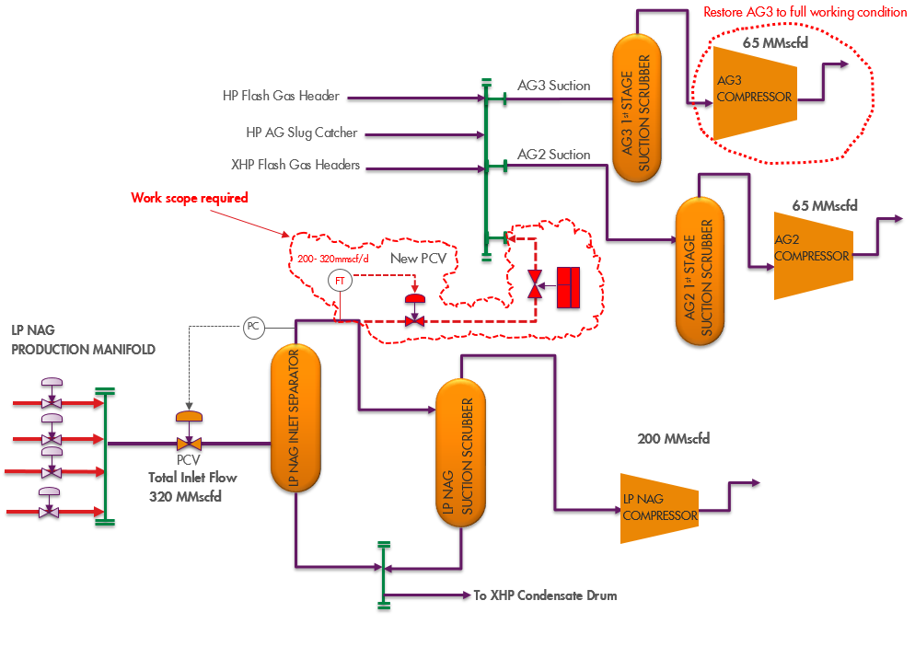

Fig 1. Process Flow Schematic – LP NAG Routing to AG Compressor

# Project Background

To keep one train of the Soku AG compressor (65 MMscfd capacity) running in stable operation, a turndown flowrate of 40MMscfd of gas is required to the 1st stage. The feed sources to the compressor include the Soku GP, Nembe, Ekulama, Santa Barbara flowstation. However, whenever, the NCTL is down, only condensate flash gas is available and quantities (5-10 MMscfd) are insufficient to run compressor, hence flared. There are two trains of the AG/Flash gas compressor unit (each train having 65MMscfd capacity).

This opportunity involves routing LP NAG from the Inlet Separator (V-1080) gas outlet line to the AG/Flash Gas Compressor Suction Header, this will require an increase in the LP NAG flowrate from the current rate of 200MMscfd to 320 MMscfd and splitting the flow of LP NAG to the LP NAG Compressor (200 MMscfd) and AG 2/3 Compressor (120 MMscfd). 120MMScfd of LP NAG from the Inlet separator gas outlet piping will undergo pressure reduction from 40 barg to 5-6 barg as suction to the AG/Flash Gas Compressor Suction Header and subsequently to the AG2 compressor 1st stage suction scrubber for further compression.

# Project Value Drivers

The value driver for this project is Schedule and Gas volume. Much value will be derived from this project if the modification can be in place within a short time frame to take advantage of available gas volumes from the current LP NAG well stock.

# Purpose

The purpose of this document is to set out the basis for the proposed modifications required to achieve the desired goals, describe the concept as well as highlight possible challenges and planned mitigation measures considered.

# Overall Soku Gas Plant Process Description

The Soku Gas Plant (LNG Gas Supply Plant) processes combined feed stream of

* Non-associated gas (NAG) from Soku Field Reservoirs
* HP associated gas (HP AG) from Soku, Ekulama, Nembe Creek and Santa Barbara flowstation.
* XXHP associated gas (XXHP AG) from Belema and Odeama Creek Flowstation.

The Soku gas plant process facilities are as follows:

* NAG reception facilities, which mainly consist of flowlines, 20” production manifold

and 20” test/production manifold with 18 ligaments on each manifold.

* 3 NAG Processing Trains in parallel, which consist of separation (Inlet separators) and gas dehydration (Glycol Contactors and Glycol Regeneration systems), which treats the gas to a water dewpoint of 0 deg.C at 95barg.
* LP NAG Compression System: The LP NAG is compressed in a 200 MMscfd Centrifugal Compressor routed to the NAG processing train for dehydration
* AG Reception and HP Compression Trains: The HP AG gas is compressed through two identical compression trains (comprising of three stage centrifugal compressors; 65MMscfd capacity and 10MW gas turbine driver each), routed to the NAG processing trains for dehydration. The XXHP AG gas is routed directly to the inlet of the dehydration facilities in the NAG processing trains.
* Measurement and transfer of sales gas to NLNG Plant,
* Two (2) Condensate Stabilization trains, which recovers the liquid product streams from the NAG processing trains, the HP compression trains and from the XXHP slug catcher. These are flashed through 3 separation stages, heated to achieve a TVP of 0.86bara at 35oC. The gas product streams are routed to the HP compression trains, while liquid is routed to condensate storage tank.
* Condensate storage and export facilities.
* Test Separator that operates in parallel to the inlet separators,
* Flaring systems, (HP and Atmospheric flare systems) each system has 2 X 100% flare

stacks and 1 flare knockout drum.

* Utilities.

The LGSP supplies gas to the NLNG plant at Bonny Island, and condensates are currently stabilized in the condensate stabilization system and spiked to NLNG Bonny via the EGGS-1

gas pipeline.

A schematic of the Soku Gas Plant is shown in Figure 1 below.

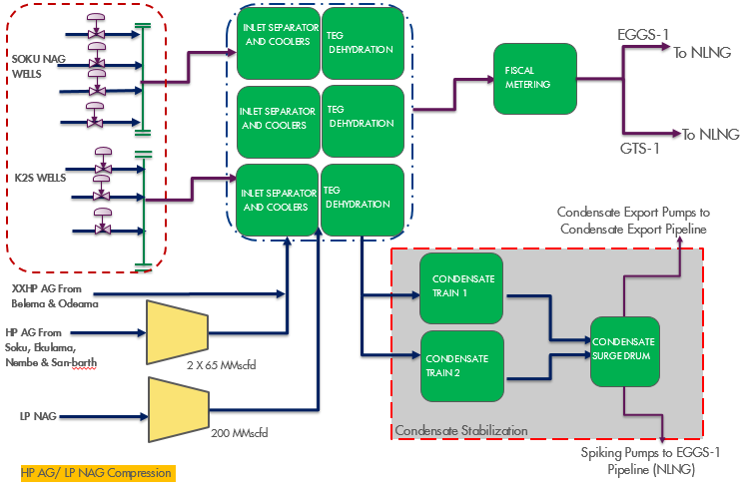

Fig 1.2. Soku Gas Plant Process Schematic

* 1. **Process Description** 
     1. **LP NAG Compression System**

Well fluid enters the Soku Gas Plant via individual 8” duplex stainless steel flowlines approximately 0.75km in length. The gas flowrate from each well is dependent on the percentage opening of the choke valves (8”) on each respective flowline. LP NAG wells are routed to the new LP manifold (L-1080).

From the LP inlet manifold, the well fluid from the depleted wells flows to the new LP inlet separator (V-1080) operating at around 40 barg. The gas from the inlet separator flows to the Compressor suction scrubber (V-2180). Gas from the suction scrubber (V-2180) is routed to the NAG compressor (K-2180) where it is compressed from 40 barg to 92 barg. After compression, gas is cooled to 45 deg.C in the NAG aftercooler (E-2180). Condensate which condenses out after cooling is separated from the gas in the existing discharge scrubber (V-2104). The gas then flows to the AG/Flash gas compressor discharge header manifold where it combines with compressed AG and flows to the existing TEG contactors for dehydration. The discharge header is currently operated at 92 barg.

Table 1.1: Design and Operating data for Soku LP NAG Compressor

|  |  |
| --- | --- |
| **Compressor** | **1st stage** |
| Type | Centrifugal |
| Model | STC-SV(06-4-A) |
| Manufacturer | SIEMENS |
| Suction Pressure/Temperature (bara/°C) | (35 – 45)/ (29-45) |
| Discharge Pressure/Temperature (bara/°C) | 99.8/(95 – 132) |
| Design Capacity | 200 MMscfd |
| Compressor speed (Min/Max) | 8418rpm/12627rpm |
| Compressor Design speed/Trip speed | 12026rpm/13258rpm |
| Driver | EGT RLM 1600 |
| Compressor driver | Gas turbine |
| Driver ISO power (MW) | 11.382 |
| Polytropic (Vol. Efficiency) | 82% |

* + 1. **AG/Flash Gas Compression System**

The AG/Flash Gas Recovery system consists of gas collection manifolds, Two AG/Flash Gas Compressor trains, complete with scrubbers and coolers, and control systems. It is fed by two streams;

• HP flash gas from HP Condensate Flash Drums and XHP flash gas from XHP Condensate Flash Drums that has also been let down into this stream.

• HP AG from the HP AG Slug Catcher comprising associated gas from Nembe/Ekulama/Soku FS

The AG/Flash Gas Recovery system compresses gas to about 98barg and feeds it into the Gas Processing Trains. The AG/Flash Gas Compression system consist of Two trains of 3-stage gas turbine driven centrifugal compressors each designed for 65MMscfd at a suction pressure of 5 Barg.

Each of the three stages of each compression train comprises a suction scrubber, compressor and discharge cooler. The third stages has a discharge scrubber downstream of the after-coolers. Liquids separated in each scrubber are routed under level control to the previous suction scrubber. Liquids from the first stage suction scrubber are sent to the HP Flare knockout drum.

The operation of the AG/Flash Gas Compression system is controlled by a combination of driver speed variation and gas recycling at each stage. Each stage of each of the AG/Flash Gas Compressors has its own dedicated anti-surge control system, which operates independently from the overall compressor capacity controller.

Table 1.2: Design and operating data for Soku AG/Flash gas compressors

|  |  |  |  |
| --- | --- | --- | --- |
| **Compressor** | **1st stage** | **2nd stage** | **3rd stage** |
| Type | Centrifugal | Centrifugal | Centrifugal |
| Model | 8BK26 | 8BK26 | 6B22 |
| Manufacturer | Demag Delaval | | |
| Suction Pressure/Temperature (bara/°C) | 6/38 | 15.7/50 | 38/40 |
| Discharge Pressure/Temperature (bara/°C) | 16.4/120 | 38.7/138 | 98/110 |
| Design Capacity | 65 MMscfd | 65 MMscfd | 65MMscfd |
| Compressor speed (Min/Max) | 8418rpm/12627rpm | | |
| Compressor Design speed/Trip speed | 12026rpm/13258rpm | | |
| Driver | EGT RLM 1600 | | |
| Compressor driver | Gas turbine | Gas turbine | Gas turbine |
| Driver ISO power (MW) | 11.382 | 11.382 | 11.382 |
| Polytropic (Vol. Efficiency) | 69.5-84.3% | 69.5-84.3% | 69.5-84.3% |

# Equipment Capacity Checks

* + 1. **LP NAG Inlet Line/Piping Capacity Check**

Capacity Checks were carried out on the LP NAG Inlet Line to determine the maximum gas rate the line/piping can handle at 40 barg Inlet Pressure.

* 20-inch Gas Inlet Line to LP NAG Inlet Separator at 40 barg can handle a maximum rate of **366 MMscfd** at a maximum velocity of 20 m/s
* 16-inch Gas Outlet Line from the LP NAG Inlet Separator can handle a maximum rate of **297 MMscfd** at a maximum velocity of 20m/s

However, the DEP (Piping General Requirements - DEP 31.38.01.11-Gen.) also recommends using the momentum criterion of ≤ 50,000 Pa up to maximum velocity of 60m/s for sizing. Based on this criteria, allowable velocity can go as high as 36.74 m/s. this new velocity limit allows a maximum rate of **672 MMscfd for the 20” Gas Inlet Line** and **546 MMscfd for the 16” Gas Outlet Line**.

* + 1. **Vessel/ Nozzle Capacity Check**

Capacity Checks was also carried out on the Inlet and Outlet Gas Nozzle of the LP NAG Inlet separator to determine maximum capacity through the Nozzle. Rating calculations indicate that the 20” Gas outlet nozzle is limited to 201 MMscfd at 40 barg while the 20” Inlet Nozzle limits the maximum gas rate to 269 MMscfd. However, this is a soft limit/criterion which can be exceeded due to the presence of downstream suction scrubber which can handle entrained liquid in the gas.

Capacity checks was also carried out on the LP NAG Inlet Separator to determine the gas handling capacity of the separator at current operating conditions, the Gas handling capacity of the inlet separator was calculated as 258 MMscfd and liquid handling is 41 Mbpd.

Results of Capacity Check on the LP NAG Inlet Separator

|  |  |  |
| --- | --- | --- |
| **SOKU LP NAG INLET SEPARATOR** | | |
| **Limits** | **Gas (MMscfd)** | **Liquid (Mbpd)** |
| Gas/Liquid handling | 258 | 40.85 |
| PCV/LCV | **340** | **52.95** |
| Inplot Piping | 297* | 60.92 |
| Outlet nozzles | 201* | 33.51 |

*\*limits on the Inplot piping can be exceeded based on new momentum criteria to 672 MMscfd while limits on the outlet nozzle ensure separation efficiency which can be exceeded due to presence of downstream scrubbers for handling entrained liquid.*

* + 1. **AG Compressor Checks/Proof of Concept**

Comparism Checks were carried out on the Molecular weight and Composition of Associated Gas currently routed to the AG2 compressor to determine variances with the NAG composition and Molecular Weight (MW). AG is collected from several fields and third-party fields in the greater Soku Area namely;

* Soku (HP)
* Ekulama (HP)
* Nembe Creek (HP)
* Belema (XXHP)
* Odeama Creek (XXHP)

The composition of the Associated Gas is as follows.

|  |  |  |  |  |  |
| --- | --- | --- | --- | --- | --- |
|  | **XXHP AG**  **Belema/Odeama** | **HP**  **AG Ekulama** | **HP**  **AG Soku** | **HP AG**  **Nembe Creek** | **NAG Well**  **Composition** |
| Components | Mole % | Mole % | Mole % | Mole % | Mole % |
| Nitrogen | 0.06 | 0.1 | 0.17 | 0.05 | 0.055 |
| CO2 | 1.4 | 0.61 | 0.45 | 0.75 | 0.18 |
| Methane | 82.7 | 90.55 | 88.87 | 92.83 | 88.6 |
| Ethane | 8.3 | 5.29 | 6.21 | 3.65 | 3.60 |
| Propane | 3.9 | 2.18 | 2.65 | 1.49 | 1.55 |
| i-Butane | 1.4 | 0.13 | 0.07 | 0.42 | 0.55 |
| n-Butane | 1.2 | 0.62 | 0.82 | 0.43 | 0.67 |
| i-Pentane | 0.4 | 0.2 | 0.19 | 0.16 | 0.398 |
| n-Pentane | 0.3 | 0.16 | 0.19 | 0.11 | 0.312 |
| Hexane Plus | 0.33 | 0.15 | 0.38 | 0.11 | 2.26 |
| H20 | 0.007 | 0 | 0 | 0 | 1.88 |

Molecular weight of AG used for design of the AG2 compressor ranges between 18.60 – 24 based on the Performance curve shown below, The molecular weight of the NAG is approximately 20.2 which is within range. **In addition, the AG2 compressors have been operated using NAG through the buy-back route which provides the proof of concept.**

Additional checks was also carried out by the vendor/OEM (SIEMENS) on the viability of this concept (Appendix 4 – OEM Compatibility Checks), The checks revealed the viability of this option. The LP NAG inlet separator handles the liquid entrained in the gas prior to routing to the AG2 1st stage suction scrubber, liquid drop out is expected after the pressure drop which can be adequately handled by the Suction scrubber of the AG2 compressor.

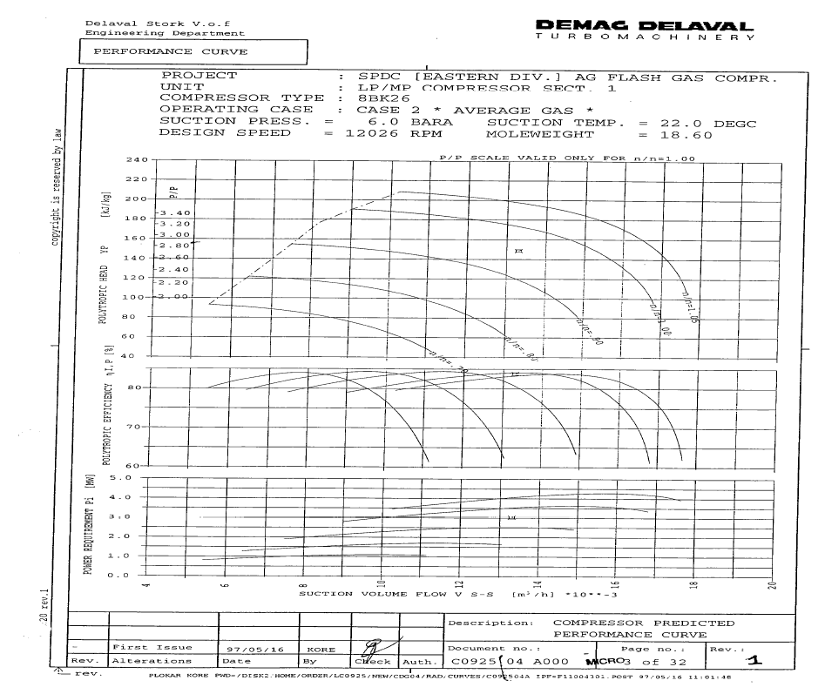

Fig 1.3. AG2 Compressor Performance Curve

1. **Proposed Modifications**
   1. **Concept Selected**

The concept selected involves routing LP NAG from the LP NAG Inlet Separator gas outlet line to the AG/Flash Gas Compressor Suction header for onward compression in the AG2 and AG3 compressor, this will require an increase in the LP NAG flowrate from the current rate of 200MMscfd to 320 MMscfd and splitting the flow to the LP NAG Compressor (200 MMscfd) and AG Compressor (120 MMscfd). 120MMscfd of LP NAG from the Inlet separator gas outlet piping will undergo pressure reduction from 40 barg to 5 barg as suction to the AG/Flash Gas Compressor Suction Header and subsequently to the AG2 and AG3 compressor 1st stage suction scrubber for further compression.

As at November 2017, The total LP NAG well production potential is circa 460 MMscfd (Appendix 2). With additional HP wells depleting in pressure this potential is bound to increase.



Fig 1.2. Schematic of Selected Concept

* 1. **Process Control Philosophy**

The process control strategy employed will be Pressure control with a Flow Override, a new flow transmitter and PCV will be installed on the new piping/inlet line to the AG suction header to modulate flow in excess of 200 MMscfd (200 -320 MMscfd) to the AG2 and AG3 compressor. The LP NAG Compression control system (CCC) will control flow to the LP NAG Compressor.

Details of the control scheme will be explained in the Process control narrative which will be developed in the design stage of the project.

* 1. **Compositional Basis/Hydrate Management**

**NAG Composition**

|  |  |
| --- | --- |
| **Component** | **Mole Fractions** |
| Nitrogen | 0.00055 |
| CO2 | 0.00179 |
| Methane | 0.88553 |
| Ethane | 0.03604 |
| Propane | 0.01547 |
| i-Butane | 0.00547 |
| n-Butane | 0.00671 |
| i-Pentane | 0.00398 |
| n-Pentane | 0.00312 |
| n-Hexane | 0.00446 |
| n-Heptane | 0.00130 |
| n-Octane | 0.00151 |
| n-Nonane | 0.00065 |
| n-Decane | 0.00042 |
| n-C11 | 0.00015 |
| H2O | 0.01879 |
| TEGlycol | 0.00000 |
| _CP * | 0.00008 |
| _CH * | 0.00116 |
| _NC5 * | 0.00006 |
| _NC6 * | 0.00079 |
| _ECH * | 0.00241 |
| _NC8 * | 0.00021 |
| _BCH * | 0.00110 |
| _NC10* | 0.00006 |
| _12A * | 0.00050 |
| _NC12* | 0.00003 |
| _15A * | 0.00035 |
| _NC16* | 0.00000 |
| _19A * | 0.00006 |
| _X240* | 0.00005 |
| _EBZN* | 0.00010 |
| _NPHT* | 0.00023 |
| _1ENP* | 0.00003 |
| _X180* | 0.00005 |
| _MCH * | 0.00242 |
| _NC7 * | 0.00056 |
| _PBZN* | 0.00031 |
| _BCYP* | 0.00170 |
| _11B * | 0.00017 |
| _11N * | 0.00079 |
| _13B * | 0.00008 |
| _13A * | 0.00054 |
| _X210* | 0.00002 |
| _17A * | 0.00009 |
| _23B * | 0.00001 |
| _NC9 * | 0.00000 |
| _NC14* | 0.00004 |
| _TOLU* | 0.00001 |
| _NC11* | 0.00000 |

**Pseudo- Components**

|  |  |  |  |  |  |  |
| --- | --- | --- | --- | --- | --- | --- |
| **Name** | **NBP [C]** | **MW** | **Liq Density [g/cm3]** | **Tc [C]** | **Pc [bar_g]** | **Vc [ft3/lbmole]** |
| _CP * | 44.7019 | 70.1400 | 0.7505 | 231.6358 | 43.4767 | 4.1390 |
| _CH * | 80.4444 | 84.1600 | 0.7834 | 274.9389 | 38.6212 | 4.9642 |
| _NC5 * | 21.6679 | 72.1500 | 0.6312 | 183.2636 | 33.3949 | 4.8443 |
| _NC6 * | 60.7020 | 86.1800 | 0.6640 | 226.9952 | 29.4027 | 5.8449 |
| _ECH * | 131.4188 | 112.2200 | 0.7922 | 326.1979 | 29.6218 | 6.8614 |
| _NC8 * | 117.8585 | 114.2300 | 0.7069 | 289.7817 | 24.1960 | 7.7460 |
| _BCH * | 174.0126 | 140.2700 | 0.8032 | 367.3425 | 24.2770 | 8.7368 |
| _NC10* | 162.1508 | 142.2900 | 0.7341 | 335.9253 | 20.5795 | 9.6387 |
| _12A * | 214.3527 | 162.2800 | 0.8617 | 419.7635 | 23.6019 | 9.6559 |
| _NC12* | 199.2541 | 170.3400 | 0.7526 | 372.4007 | 17.8215 | 11.5627 |
| _15A * | 260.8101 | 204.3600 | 0.8591 | 457.4916 | 18.5642 | 12.5547 |
| _NC16* | 260.8026 | 226.4500 | 0.7773 | 429.0304 | 13.8973 | 15.5138 |
| _19A * | 312.9223 | 260.4600 | 0.8582 | 497.4760 | 14.2656 | 16.5542 |
| _19N * | 308.6750 | 266.4800 | 0.8262 | 482.2799 | 12.9488 | 17.6298 |
| _28B * | 416.0876 | 380.6200 | 0.8985 | 588.2752 | 10.0001 | 24.5593 |
| _29A * | 412.8058 | 400.6900 | 0.8536 | 566.8092 | 8.4463 | 27.4566 |
| _X240* | 363.4594 | 240.0000 | 1.0999 | 615.0259 | 23.6761 | 12.0262 |
| _X350* | 466.6417 | 350.0000 | 1.0999 | 702.0661 | 15.7014 | 18.5913 |
| _X470* | 554.8693 | 470.0000 | 1.0999 | 771.5889 | 11.2241 | 26.1485 |
| _X490* | 496.9566 | 490.0000 | 0.9333 | 659.9071 | 7.8350 | 31.9101 |
| _38B * | 490.2953 | 520.8700 | 0.8763 | 628.7025 | 6.3812 | 36.3795 |
| _X580* | 622.5067 | 580.0000 | 1.0999 | 823.1449 | 8.8090 | 33.2895 |
| _X600* | 560.9000 | 600.0000 | 0.9449 | 708.9854 | 6.2540 | 39.8474 |
| _EBZN* | 135.7225 | 106.1700 | 0.8718 | 349.2552 | 36.2322 | 5.9158 |
| _NPHT* | 200.1303 | 128.1700 | 1.0309 | 445.3012 | 38.8919 | 6.3095 |
| _1ENP* | 238.7168 | 156.2300 | 1.0119 | 480.5770 | 31.5870 | 8.0021 |
| _X180* | 291.2436 | 180.0000 | 1.0999 | 548.4542 | 31.2453 | 8.7143 |
| _BNZN* | 84.6257 | 78.1100 | 0.8846 | 296.9412 | 49.0812 | 4.1112 |
| _MCH * | 104.8122 | 98.1900 | 0.7740 | 296.6702 | 32.5920 | 6.0037 |
| _NC7 * | 91.5555 | 100.2100 | 0.6881 | 261.2161 | 26.5075 | 6.8026 |
| _PBZN* | 157.5655 | 120.2000 | 0.8666 | 369.5248 | 31.9116 | 6.8477 |
| _BCYP* | 153.5796 | 126.2400 | 0.7978 | 347.8165 | 26.6661 | 7.7991 |
| _11B * | 220.8916 | 142.2000 | 1.0243 | 465.4257 | 35.0718 | 7.1270 |
| _11N * | 192.8505 | 154.3000 | 0.8076 | 384.7951 | 22.2605 | 9.6835 |
| _13B * | 253.0784 | 170.2600 | 0.9915 | 489.6412 | 28.2454 | 8.9696 |
| _13A * | 230.8089 | 176.3000 | 0.8609 | 433.5066 | 21.6852 | 10.6084 |
| _X210* | 329.2774 | 210.0000 | 1.0999 | 584.2147 | 27.0256 | 10.3467 |
| _17A * | 288.1059 | 232.4100 | 0.8588 | 478.8379 | 16.1832 | 14.5289 |
| _X300* | 423.2532 | 300.0000 | 1.0999 | 666.4052 | 18.6299 | 15.5541 |
| _23B * | 371.9717 | 310.4900 | 0.9177 | 564.4820 | 13.2372 | 19.0085 |
| _NC9 * | 141.0861 | 128.2600 | 0.7217 | 314.2633 | 22.2425 | 8.6919 |
| _NC14* | 231.7753 | 198.3900 | 0.7667 | 402.9724 | 15.6608 | 13.5158 |
| _TOLU* | 110.6198 | 92.1400 | 0.8719 | 323.3802 | 41.3713 | 5.0313 |
| _NC11* | 181.4000 | 156.3100 | 0.7443 | 353.1000 | 19.6568 | 9.9955 |

Hydrate formation is not envisaged during the Let-down from 40 Barg /30 deg.C to 5 barg. The temperature at the pressure expected downstream the PCV is ~12degC, which is above the hydrate formation temperature of -8 deg.C. However, the well stream heaters should be available and functional. This will ensure the gas is sufficiently heated before let-down to 5 barg. This will prevent any potential ice/hydrate formation.

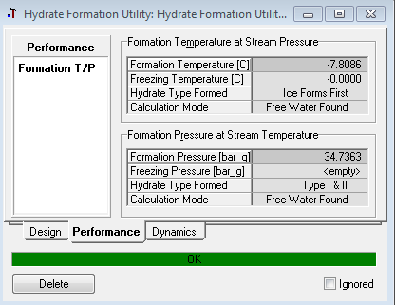

* 1. **Work scope**

This section itemizes the scope of the modification(s) required at Soku Gas Plant and will also form the basis for Detailed Engineering Design, This include;

* Piping modification on the LP NAG Inlet Separator Gas Outlet Line to ensure tie-in of proposed Line to the AG/Flash Gas suction header.
* Design and Installation of New Pressure control valve to handle 120 MMscfd maximum rate and 40 MMscfd (Minimum/Turndown Rate)
* Checks on Relief Valve on the AG/Flash Gas Compressor for Adequacy.
* Restoration of AG3 compressor to full working condition.
* Instrument Integration to ensure all new instruments are integrated to Soku GP Control and Safeguarding system.
* Other engineering checks as needed for brownfield modification.

1. **Risk and Uncertainties**

The risk and uncertainties have been identified and assessed, below are a summary of the top risk and uncertainties identified.

|  |  |  |  |
| --- | --- | --- | --- |
|  | **Risk Title** | **Description** | **Mitigation** |
| 1 | Production of high liquid because of Pressure drop to 5 barg. | Liquid drop-out as a result of LP NAG pressure drop from 40 barg to 5 barg which may lead to entrainment if adequate liquid handling capacity is not in place. | Liquid handling Capacity Checks have been done on the LP NAG Inlet Separator and the AG2 Suction Scrubbers and liquid handling capacity has been found adequate. |
| 2 | Compressing NAG through the AG2/3 Compressor | Molecular weight differences in NAG/AG may impact power requirement and actual volumetric flow to the compressor. | Comparism checks have been done between MW of AG and NAG and was found to be within range. Soku AG Compressors have been operated using NAG through the buy-back route (status quo retained) |
| 3 | Preferential flow of NAG to AG2/3 Compressor rather than LP NAG Compressor due to lower static pressure (5 barg) | Excess flow to AG2/3 Compressor and potential starvation of LP NAG Compressor. | Implemented control strategy will ensure preference is given to the LP NAG Compressor. |
| 4 | Brownfield Project Execution Uncertainties | Inherent brownfield uncertainties of executing a project which includes minor modifications on an existing installation, required brownfield modification scope may introduce additional safety risk. | Site visits, Constructability workshop, Simultaneous operations philosophy to be detailed during design. |

# Scope of Design Work and Deliverables

The Detailed Engineering Design Scope of work also includes validation of the following;

* Line Sizing
* Control Valve Sizing and Specification
* Process Design Report
* Piping Stress Analysis
* Piping Isometrics
* Piping Base Foundation Design
* Materials Take-off and Construction Scope/Package
* Systematic HAZOP analysis and SIL classification.
* Update of all affected drawings and documentation
  1. **Deliverables/Activities**

Process Engineering

* Preparation/Update of PFS/PEFS/PSFS
* Preparation/Update of Heat and Mass balance
* Update of Soku GP Safeguarding Memorandum
* Preparation of Process Design Report
* Update of Soku GP Operating and control Philosophy
* Design and Specification of new equipment’s (Control Valve/Shutdown Valves).
* Design and specification of gas Inplot piping system
* Input to Control valve sizing

PACO

* Update control and safeguarding narrative
* Instrument datasheets (pressure, temperature, control valves)
* Control valve sizing
* Instrument tagging (Instrument index) and MTO
* SIF TOR and SIF report
* Instrument cable schedule and routing layout, Instrument cable tray and JB wiring and layout
* Cause and Effects charts
* Block diagrams and Loop drawings
* Instrument hook-up drawings
* Design integration of the new instruments into the existing Soku GP PAS and SIS system such that seamless integration can be achieved.
* Design and review of Soku NAG process control scheme to ensure instrumentation and control can provide the process control functionality required.

Mechanical (Piping)

* Constructability Study Report
* Updated Plot plan drawings and Overall plant layout
* Demolition drawings
* Isometric drawings
* Pipe support drawing and schedule
* Tie-in points and schedule
* MTO
* Stress analysis
* Functional specification
* PDMS model (new, update existing)
* Pipe stress analysis report

Civil

* Civil Design report
* Layout, elevations drawings
* Updated plot plan
* Design of pipe supports and new support foundation layout
* Bulk MTO

Electrical

* Verify adequacy of UPS system for additional loads
* Verify adequacy of switch gear for additional loads- Instruments.

HSSE

* HSSE-SP Activity plan
* HSSE-SP Premise/philosophy
* Carry out HAZOP review (TOR, Report and Close out report).

# References

* Soku GP As-Built Drawings
* Soku GP Operating Envelope

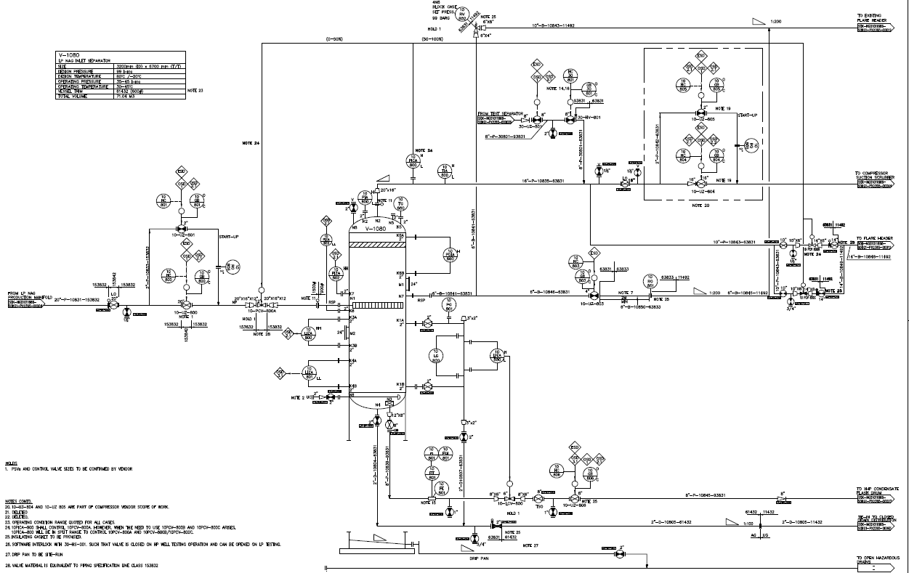

**PCV**

**To AG/Flash Gas Suction Header**

Proposed Tie-in Point

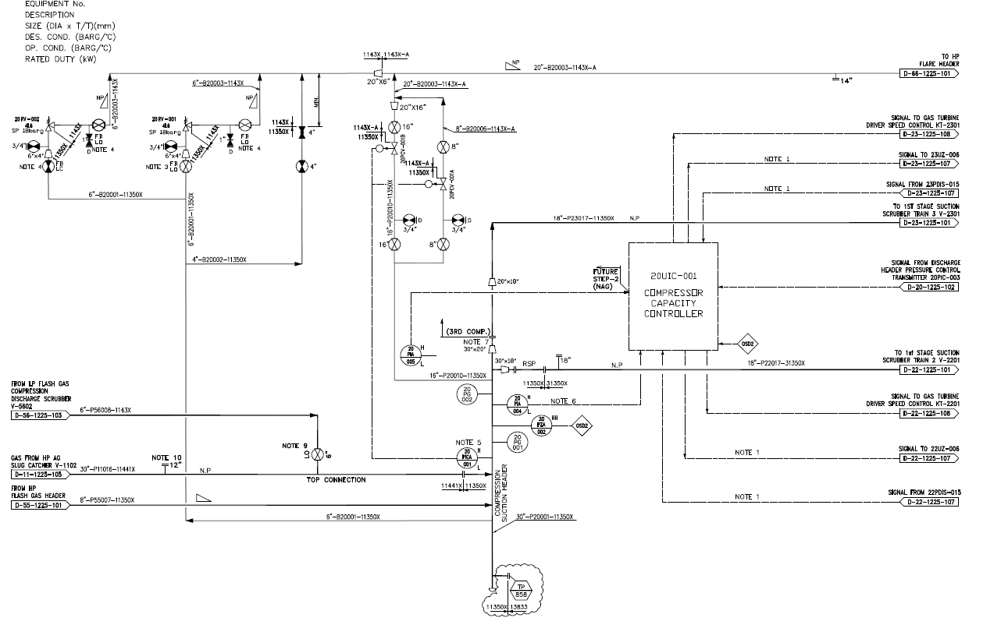

Proposed Tie-in Point

From LP NAG Inlet Separator Gas Outlet Line

Appendix 1: Proposed Marked-up Drawings showing Tie-in scope

Appendix 2: LP NAG Well Production Data – November 2017

|  |  |  |  |  |  |  |  |  |  |  |  |
| --- | --- | --- | --- | --- | --- | --- | --- | --- | --- | --- | --- |
| **Date** | **Well 34** | | **Well 39** | | **Well 41** | | **Well 47** | | **Well 52** | |  |
| **November** | FLP (Barg) | Flowrate  (MMscfd) | FLP (Barg) | Flowrate  (MMscfd) | FLP (Barg) | Flowrate  (MMscfd) | FLP (Barg) | Flowrate  (MMscfd) | FLP (Barg) | Flowrate  (MMscfd) | **Total Flowrate (MMscfd)** |
| 01/11/2017 | 61 | 121 | 60 | 20 | 53 | 62 | 54 | 186 | 91 | 85 | **474** |
| 02/11/2017 | 61 | 123 | 59 | 20 | 52 | 63 | 57 | 180 | 94 | 74 | **460** |
| 03/11/2017 | 61 | 122 | 60 | 18 | 51 | 68 | 55 | 184 | 94 | 73 | **465** |
| 04/11/2017 | 61 | 122 | 61 | 20 | 51 | 68 | 54 | 184 | 94 | 73 | **467** |
| 05/11/2017 | 62 | 106 | 64 | 18 | 52 | 51 | 55 | 164 | 88 | 89 | **428** |

Fig 1.4. LP NAG Production Data for November 2017 Indicating LP NAG Well Potential

Appendix 4 – Soku GP Limit Diagram showing LP NAG Well Potential

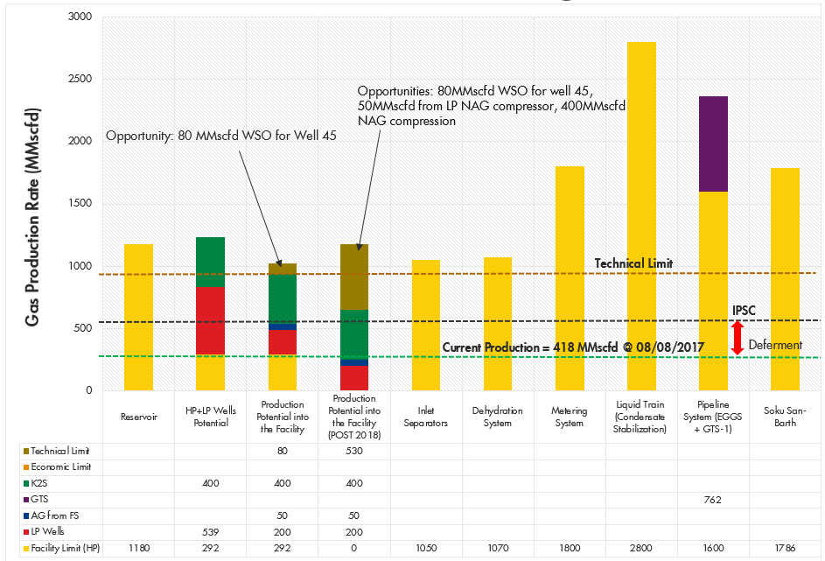

# Appendix

* Datasheet for PCV and LCV



* PEFS



* OEM/Vendor Compatibility Checks

